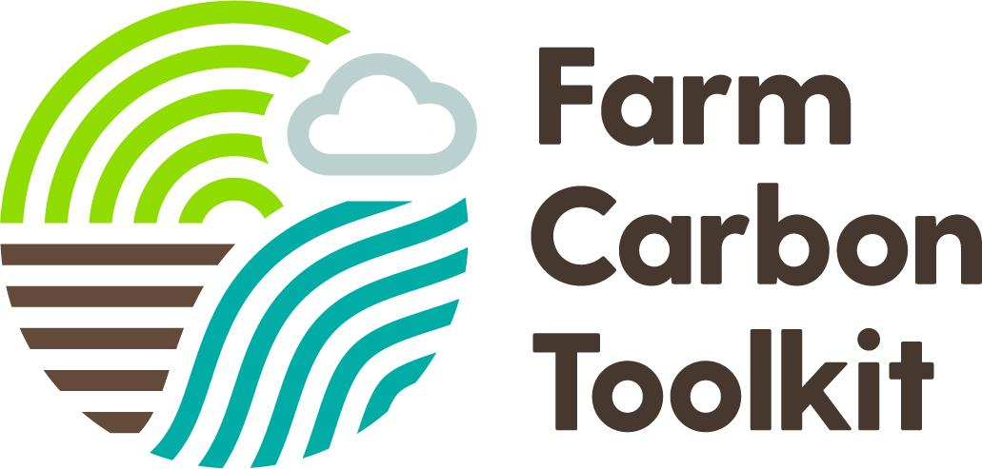

Farm Carbon Toolkit Terms and Conditions

for users of the WineGB Carbon Calculator (powered by the Farm Carbon Calculator)

What’s covered in these terms
These Terms and Conditions (“Agreement”) set out what you can expect from us as you use the Farm Carbon Toolkit (FCT) website and our services, and what we expect from you. They reflect the way that FCT works and the laws that apply to our organisation. As a result, this Agreement helps define our relationship with you as you interact with our services. For example, it includes the following topics:
- What you can expect from us, which describes how we provide and develop our website, which includes the online toolkit and Farm Carbon Calculator;
- What we expect from you, which establishes certain rules for using our services
- In case of problems or disagreements, what legal rights you have and what to expect if you violate this Agreement.
Understanding this Agreement is important because, to use our services, you must accept this Agreement.
Besides this Agreement, we also publish a Privacy Policy. Although it’s not part of this Agreement, we encourage you to read it to better understand how you can update, manage, export and delete your information.

1. Version

These Terms and Conditions were last updated on 19th January 2022..

2. Acceptance of these terms
By using our website and services, you agree to all of the Terms and Conditions. If you do not agree to abide by this Agreement, you are not authorised to access or use our services.

3. Limitation on liability
FCT accepts no liability for anything on its website, the Farm Carbon Calculator (‘the Calculator’) or any publications produced. Although our website may link to other resources (such as websites, mobile applications, etc.), we are not, directly or indirectly, implying any approval, association, sponsorship, endorsement, or affiliation with any linked resource, unless specifically stated herein.
The advice offered on this website aims to support a transition towards low-carbon, sustainable farming and food production. We strive for all statements made to be based on published data and case studies and these are to our best knowledge, correct at the time of writing. No guarantee or warranty is made, expressed or implied, concerning agricultural performance as a result of using such advice.
3.1 Farm Carbon Calculator Disclaimer
FCT are not responsible for the effect that any errors in calculations or within the original data used may have on organisations or individuals. We strive to update the Calculator periodically according to the latest science and development work by the Calculator development team.
FCT does not accept any responsibility for loss occasioned to any person or organisation acting, or refraining from action, as a result of any material in the product.

4. Accounts & Account Security
If you create an account to use the Farm Carbon Calculator, you are responsible for maintaining the security of your account and you are fully responsible for all activities that occur under the account and any other actions taken in connection with it.
We may, but have no obligation to, monitor and review new accounts. Providing false contact information may result in the termination of your account. You must immediately notify us of any unauthorised uses of your account or any other breaches of security. We will not be liable for any acts or omissions by you, including any damages of any kind incurred as a result of such acts or omissions. We may suspend, disable, or delete your account (or any part thereof) if we determine that you have violated any provision of this Agreement or that your conduct or content would tend to damage our reputation and goodwill. If we delete your account for the foregoing reasons, you may not re-register for our Services. We may block your email address and Internet protocol address to prevent further registration.

5. Free use of the Farm Carbon Calculator
Anyone is welcome to use the Calculator for free provided they do so on a directly non-commercial basis. Examples of this would be farmers and growers using it to understand and improve the carbon footprint of their business. For commercial users, such as consultants, please see below.
The Calculator can be accessed via our website www.farmcarbontoolkit.org.uk. You are permitted to download results and can access your account at any time to review past calculations, make amendments or use the Calculator for research. However, you are not permitted to make your results public, or use them for marketing purposes, without acknowledging the Farm Carbon Calculator.
Any claims made regarding the carbon credentials of your farm, products or business are made entirely at your own risk and should be made clear with the provisos stated in these Terms and Conditions. It is the user’s responsibility to check their calculations have been performed correctly.
The Calculator is currently designed for UK users, but can be used by anyone, with the understanding of the geographical restrictions. We acknowledge what is not included in the Calculator (listed here) and always welcome feedback to improve in the future. We are updating the Calculator on at least an annual basis, to reflect changes and improvements in research.

6. Commercial Users of the Calculator
Consultants and other users who are using the Calculator for profitable purposes are required to purchase an annual license from us and are not able to use the Calculator for free. Details about the packages for consultants are available on request, please email: calculator@farmcarbontoolkit.org.uk.
If any consultants or other for-profit users are found to be using the Calculator for profitable purposes, FCT will at first attempt to engage with the company or individual to pursue relevant fees. If that route is not successful, and as a last resort, FCT will pursue legal action to recover costs and for breach of these Terms and Conditions.

7. WineGB Carbon Calculator Users
The data from Users of WineGB Carbon Calculator (‘Users’) will be treated by FCC in the same way as any other user. In essence, no identifiable User data will be used, shared or sold without the express permission of the User. Data of all Users can be aggregated anonymously for use in data analysis, such as benchmarking, but it will never identify an individual or business.
However, Users are also required to give permission for their data to be viewed by the Owners of the WineGB Carbon Calculator (‘Owners’). This is to enable the functionality of ‘Group Admins’, whereby Owners can view and benchmark the Carbon Reports of all Users within the Group.
Importantly, Users should note the following:
- All Carbon Reports contained in your account are listed in ‘My Reports’. These are yours to own and manage;
- Your Carbon Reports can only be edited or deleted through your personal/business FCC account.
- The Group Admin will be able to automatically see any Carbon Report that you create, and any subsequent edits. They will not be able to edit your Reports.
- All Calculator Owners and Group Admins are bound by specific Terms & Conditions, which for clarity are laid out below in Appendix 1. Any breach of these Terms & Conditions will result in immediate action being taken by FCC, which could result in the suspension of that particular White Label Calculator.
If at any time you wish to leave the Group, or you have concerns about the conduct of the Group Admin, you can contact the FCC team at calculator@farmcarbontoolkit.org.uk
If requested we can transfer Carbon Reports from a Group account to an ordinary account on FCC. This way you can retain your Carbon Reports, but they would no longer be viewable by a Group Admin any further.
You have rights under the Data Protection Policy of FCC and Owners, in which you can ask the Data Controller (Owner) for:
- The right to access your personal information held by them and obtain a copy of it;
- The right to object to how they are using your personal data;
- The right to rectify incomplete or inaccurate data they hold about you;
- The right to restrict their handling of your personal data.
- The right to data portability and to ask them to transfer your personal data to a third party.
- The right to erasure and to ask to delete the personal data they hold about you;
- The right to complain to the Information Commissioner’s Office, the supervisory authority for data protection issues in England and Wales.
Data Controllers must reply to your request for information within one month.

8. Wine GB Carbon Calculator Owners
Owners of the Calculator have signed up to specific Terms and Conditions, separate from Users. These are in Appendix 1. Primarily this is detailed here for reference so that Users understand what is expected of Owners, and transparency of the GDPR process for Users.

9. Accuracy of Results from the Farm Carbon Calculator
FCT makes every effort to ensure that the Calculator is as accurate as possible. The functionality and algorithms have been scrutinised and tested thoroughly. However, please note that the results of the Calculator can have an inherent degree of inaccuracy due to the following variables:
- The quality and accuracy of users’ data, including the level of completeness;
- The variable nature and system complexity related to biological emissions and sequestration, in particular, from livestock, soils, and perennial crops. This is reflected in the ‘Confidence level’ column in the Full Results table of each report.

10. Data Privacy and GDPR
Visitors to our website may register to use our services, attend events, make a purchase, join a community or upload/download information. When you register, you may provide personal information such as your name, address, email, telephone number and other relevant information. Users of the Farm Carbon Calculator will provide various data related to their farming operation.
FCT is compliant with GDPR regulations that protect your data and rights. Further information on this can be found in our Privacy Notice. This describes the types of data we collect, for what purposes we collect it, and how it is used.
Please note that users of the Farm Carbon Calculator enter data that we store and process on secure servers. FCT is committed to maintaining the trust and confidence of all visitors to our website and users of our Calculator. We do not share any user data from the Farm Carbon Calculator that can be linked to an individual user or their business. Aggregated and anonymised data may be used by FCT for education, research, promotion and funder monitoring purposes without identifying individual farms. This database may be used to support FCT’s objective to further the understanding of greenhouse gas emissions in agriculture. This is explained further in our Privacy Notice.

10.1 Email Newsletter
When you create an account for the Calculator, you are given an option to opt-in to the FCT Email Newsletter. Website users may also opt-in to our Email Newsletter from other pages on the website. We use Mailchimp to store subscriber contact information and users can opt-out at any time, following the link at the bottom of any email newsletter. The email newsletter is intended to periodically share news, events and insights related to the Farm Carbon Toolkit and the Farm Carbon Calculator.
We will also send you a direct reminder email a year after completing your previous carbon report, so you can complete reports on an annual basis.
We will not share your personal data with any third party under any circumstances, without your express prior permission.

11. Cookie Policy
This site uses cookies. A cookie is a small text based file given to you by a visited website that helps identify you to that site.
Cookies are used to facilitate your visit as you navigate different pages on a website or return to the website at a later time. For example, cookies can help to save your login information and your screen display choices.
Only functional cookies (which improve visitor experience and help visitors) operate on the site. No advanced cookies run on the site and identifiable visitor details are not stored by the site. You will be asked to accept or decline cookies when visiting our website. If you reject cookies then please be aware that this may disable some of the functionality on our website.

12. Embedded content from other websites
Articles on this site may include embedded content (e.g. videos, images, articles, etc.). Embedded content from other websites behaves in the exact same way as if the visitor has visited the other website.
These websites may collect data about you, use cookies, embed additional third-party tracking, and monitor your interaction with that embedded content, including tracking your interaction with the embedded content if you have an account and are logged in to that website.

13. Third Party Policies
Related services and offerings linked to or from this website have their own privacy statements that can be viewed by clicking on the corresponding links within each respective website. Since we do not have control over the policies or practices of participating merchants and other third parties, we are not responsible for the privacy practices or contents of those sites. We recommend you review their policies before you provide any personal information or complete any transaction with them.
If you are unsure of any of this information or would like to know more, please contact us. If you do not wish to receive cookies from our site, please alter your computer cookie settings to disallow them or do not use our website.

14. Contact
If you have any questions, concerns or complaints regarding these Terms and Conditions, please contact us: info@farmcarbontoolkit.org.uk.

Appendix 1
This is the agreement that Owners of the WineGB Carbon Calculator have signed up to:
By signing this contract you agree to accepting and implementing the following Terms of Use for Wine GB Carbon Calculator:
Owners of the WineGB Carbon Calculator (‘Owners’) refer to the business or organisation owners or managers that have an annual licence with FCC. This section outlines the special Terms and Conditions that Owners must meet in order to own and operate the WineGB Carbon Calculator.
Owners may manage, or delegate to a member of their team, the role of Group Admin. This person(s) has the privilege to view the Carbon Reports of all members within their Group (‘Users’). They do not have editing rights but have viewing rights of any report, at any time.

In addition, Group Admins have the ability to interrogate that data, including benchmarking between a number of different users, and exporting/downloading data.
This entails the Owner to agree to, and implement, the following additional responsibilities. As Users are entrusting you with their data, you are assigned the role of a Data Controller, under the terms of the UK’s General Data Protection Regulation (GDPR). The full Terms of this Regulation can be seen here https://www.gov.uk/government/publications/guide-to-the-general-data-protection-regulation
Owners must comply with all the requirements of a Data Controller of an organisation, in order to satisfy the Information Commissioner’s Office (ICO). You may need to register with the ICO.
Users will have agreed to the Terms of Use in section A of this document in order to use the Calculator. In return they expect you to adhere to the Terms of Use here in section B of this document. This gives you permission to access Users data, subject to fulfilling the following specific actions:
- Your organisation must have a named Data Controller in place, and they must ensure that your Data Protection Policy covers all the Terms laid out here. The data Controller will be responsible for the oversight of all data generated by the WineGB Carbon Calculator. Note that you may be required to be registered with, and pay a fee to the Information Commissioner’s Office https://ico.org.uk/ . You can do a self assessment check on the ICO website to understand if you need to register: https://ico.org.uk/for-organisations/sme-web-hub/checklists/data-protection-self-assessment/
- Any breach of these Terms of Use must be reported to FCC immediately via calculator@farmcarbontoolkit.org.uk and, where relevant, to the ICO https://ico.org.uk/. This includes any data security breaches.
- Users' data should remain private, only visible to them and to you. You may read their carbon reports and use that data for data analysis purposes, but you may not share, use or sell their data with third parties, unless you have express permission from the User.
- If you intend to use data from the Group for public purposes, such as producing a benchmark, a Group Carbon Report, or other similar purposes, you must ensure that:
- Data is aggregated and anonymised
- No individual Users’ data is made public without the express permission of the User(s)
- You should have adequate security measures in place around the following:
- Access to the Group Admin account (login details)
- Any data downloaded from the Calculator must be stored securely, such that it cannot be accessed easily by any unauthorised people. Examples might include ensuring files and computer systems use industry recommended password encryption protocols, with regularly updated software, and the use of secure servers.
- Users have rights under GDPR to know what data of theirs you have, and can request for that data back and/or to be deleted at any time. You must comply with such requests within one month (this should be part of your Data Protection Policy).
Users have the right to contact FCC at any time if they have concerns about the actions of the Owners and/or Group Admin of their Group. They also have the right to ask FCC to transfer their Carbon reports to an ordinary FCC account at any point. Under this scenario, Group Admins would no longer be able to view that User’s Carbon Reports.
The lawful basis upon which you can process data from Users is one of legitimate interest. By signing up to the WineGB Carbon Calculator Users Terms and Conditions (as detailed in Section 7 of this document), Users consent to their data being used and managed by FCT and Calculator Owners on the basis of legitimate interest, within the additional bounds of these Terms.
It is good practice to review your Data Protection accountability practices on at least an annual basis.

The Farm Carbon Toolkit is the trading name for the The Farm Carbon-Cutting Toolkit Community Interest Company, a registered Community Interest Company, no. 07220963.

